LAB Logbook

GITHUB Link - <https://github.com/Keerthana427-hub/Cyber-security-and-AI> (All 10 labs)

Lab 1

**DataFrame** – The core Pandas class that represents tabular data in rows and columns, much like a spreadsheet or SQL table.

**Series** – A one-dimensional labeled array that can hold any data type, often used to represent a single column or row from a DataFrame.

**Index** – An immutable array used to label the axes of Series or DataFrames, enabling fast lookups and alignment.

**Categorical** – A class that represents a variable with a fixed number of possible values (categories), useful for memory-efficient encoding of repeated labels.

**Timestamp** – A class for representing individual points in time, offering powerful date-time functionality for time series analysis.

Lab 2

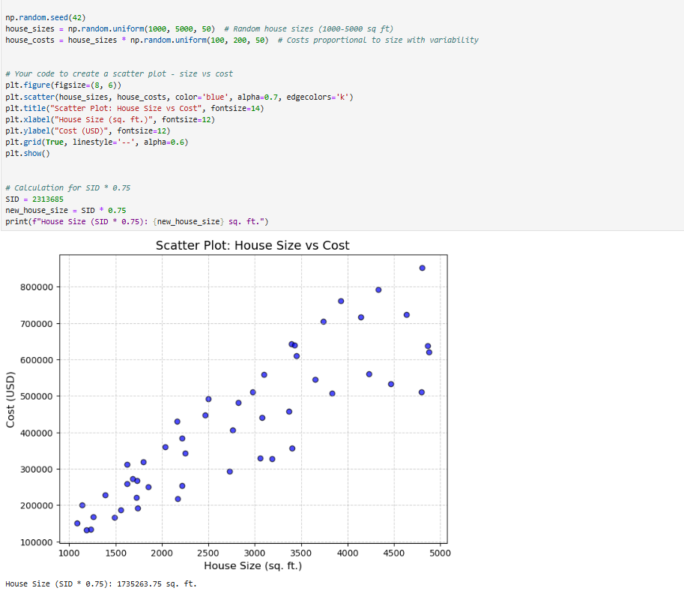

Lab 3

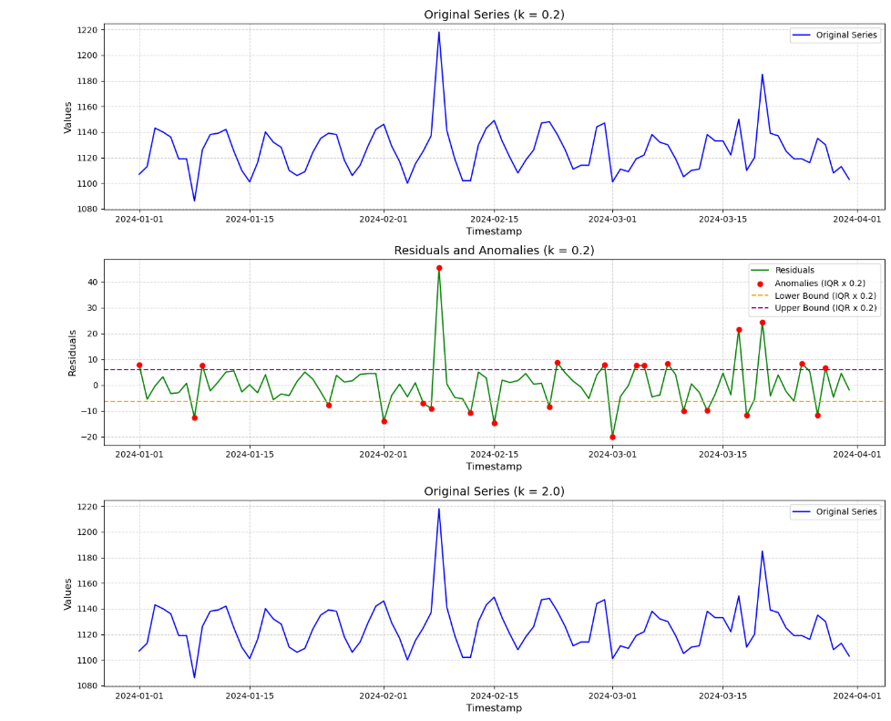

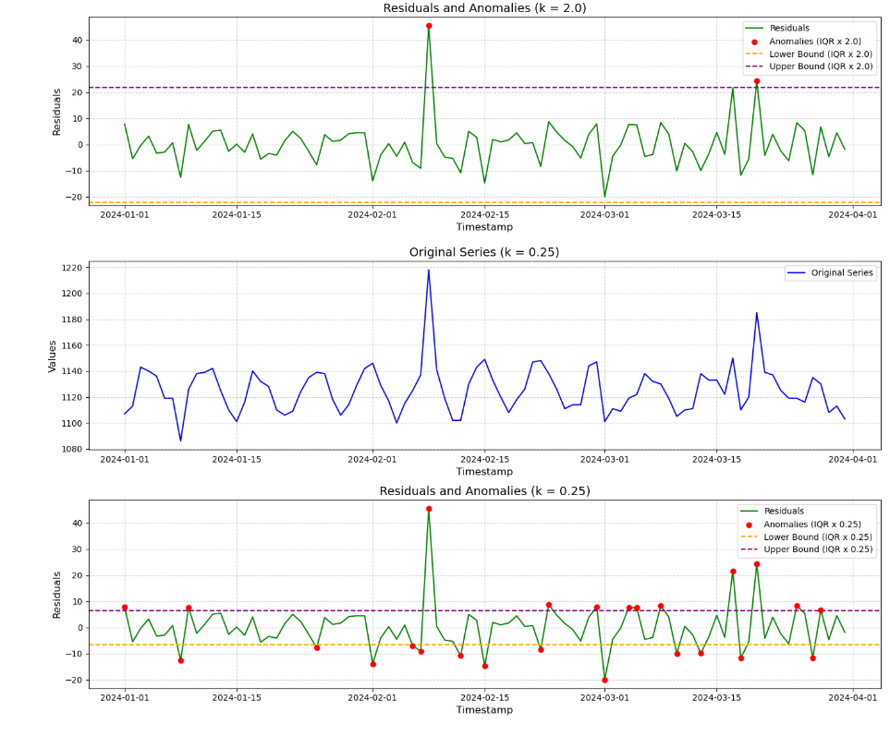

Lab 4

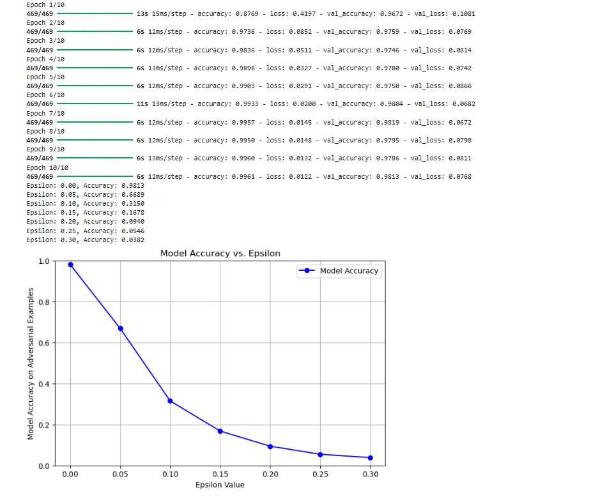

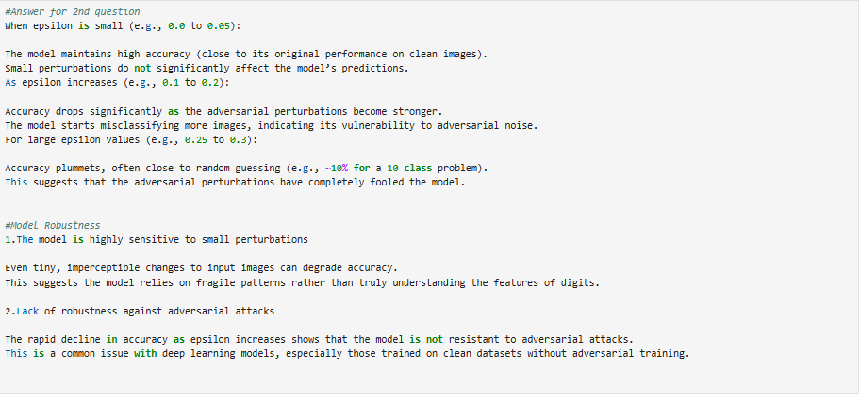

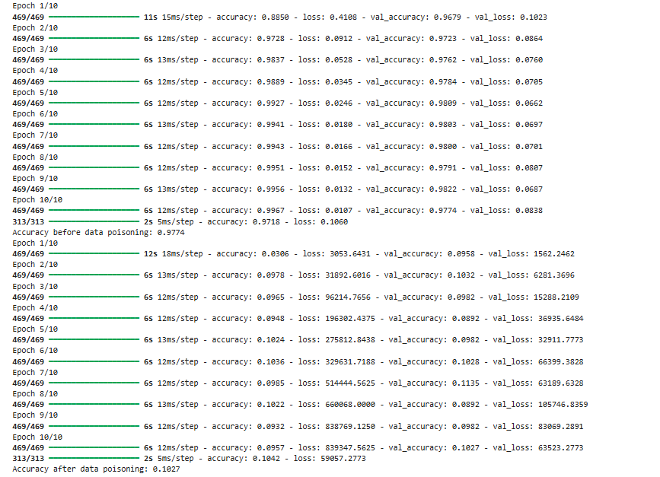

Lab 5

Lab 7

YES

Lab 8

Partner’s name - Vishnu

Lab 9

Lab 10

Lab 11

Lab 12

No Activity for Lab Logbook (Exam)